**Approach 1**

Reference determination

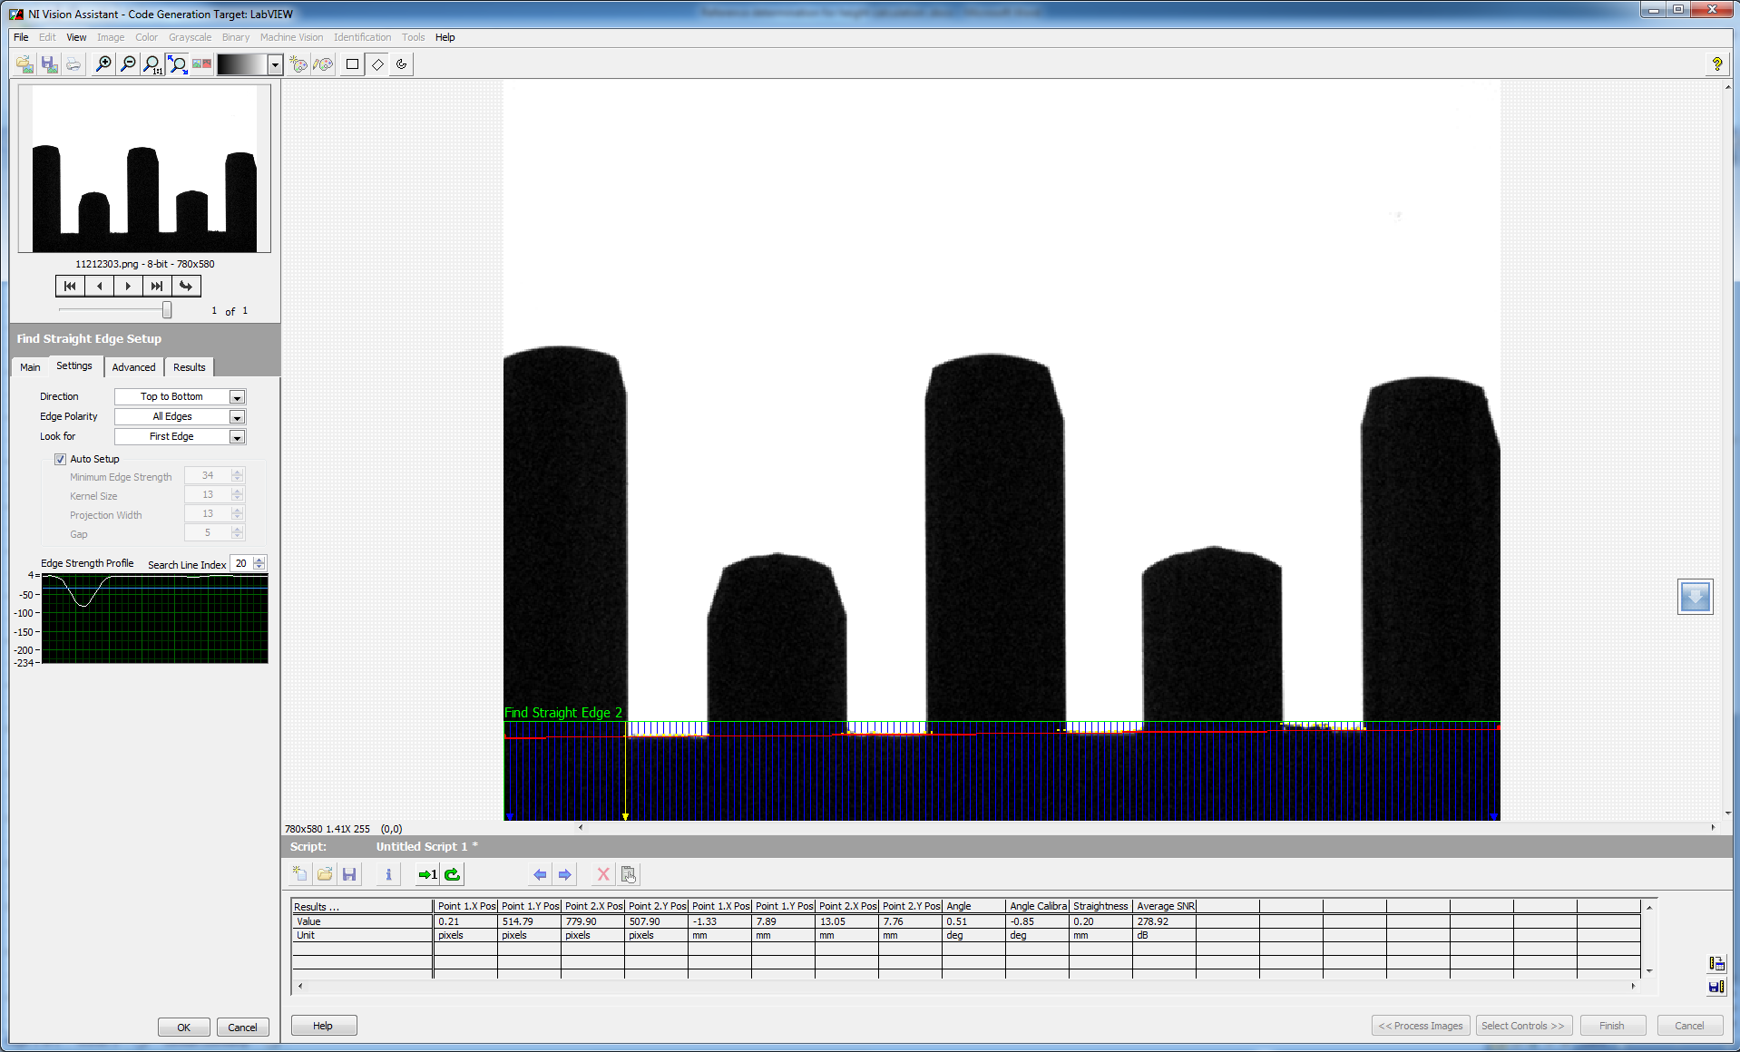

The 0.5 degree tilt of the OUI effected the line fit. It produced a difference of 4-5 pixels between end points of the line

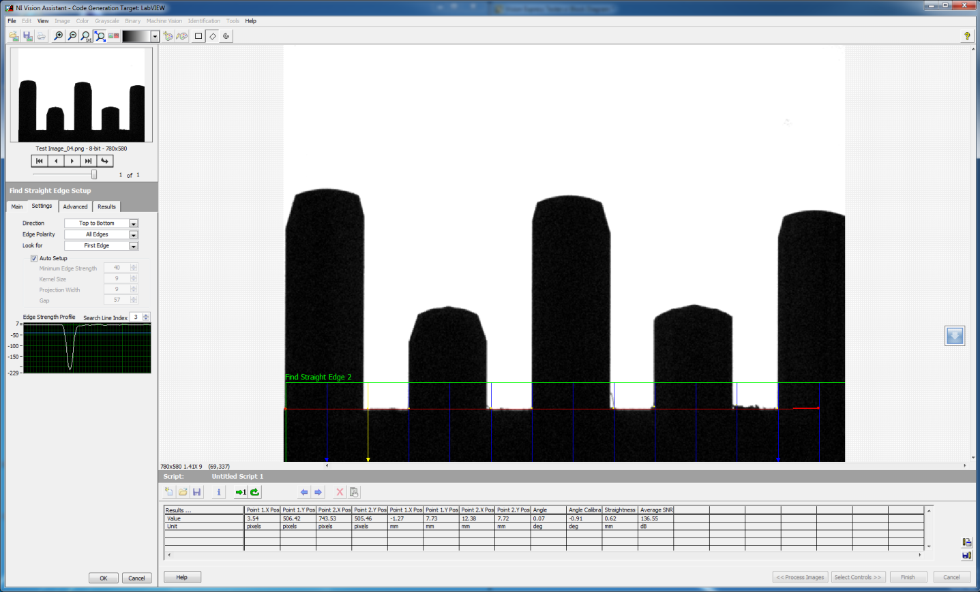

After the tilt is adjusted, the line fit was more approximate to a straight line. . It produced a difference of 1-2 pixels between end points of the line.

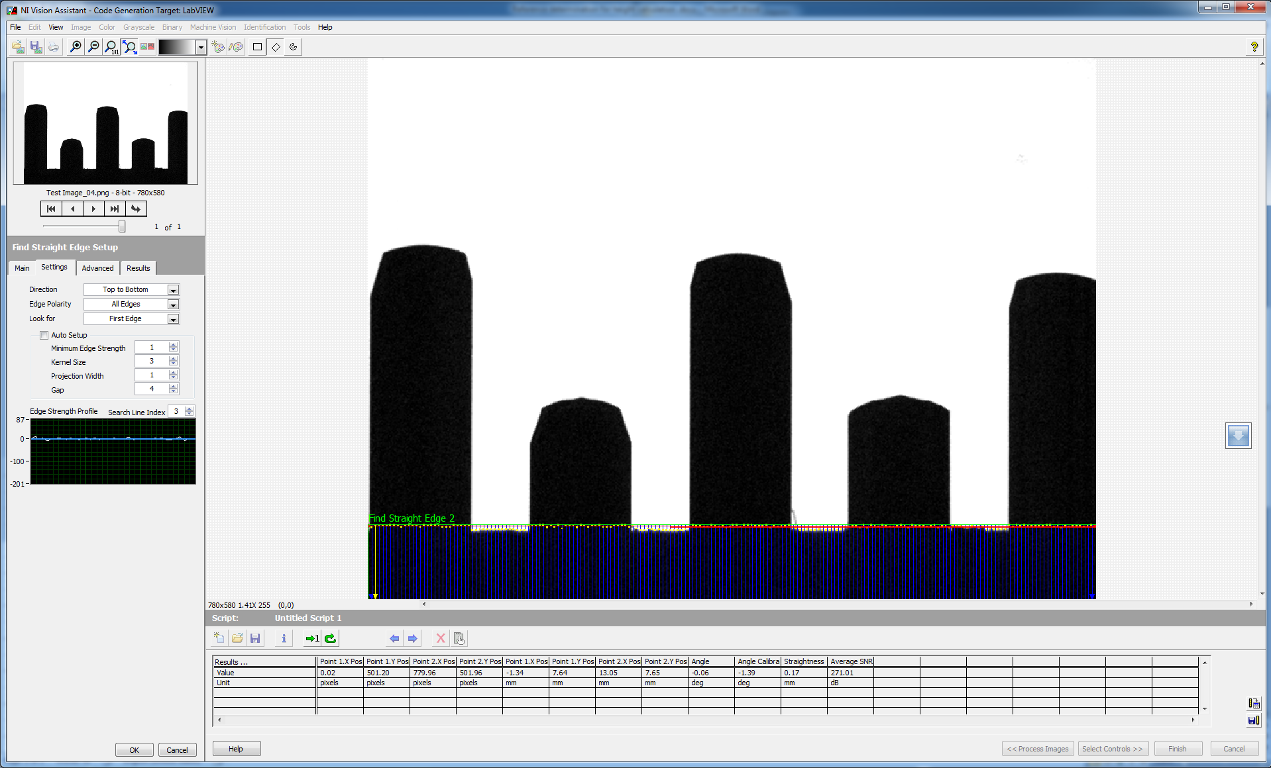

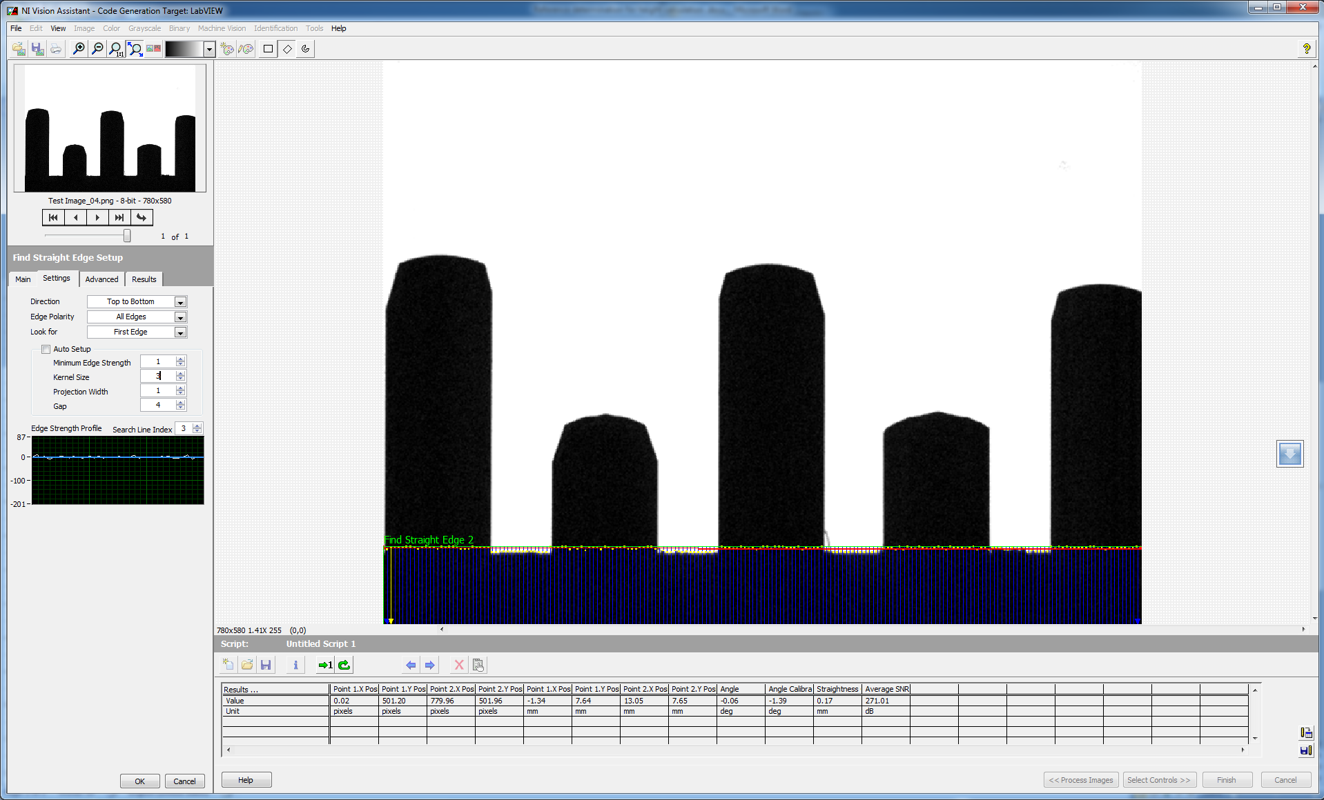

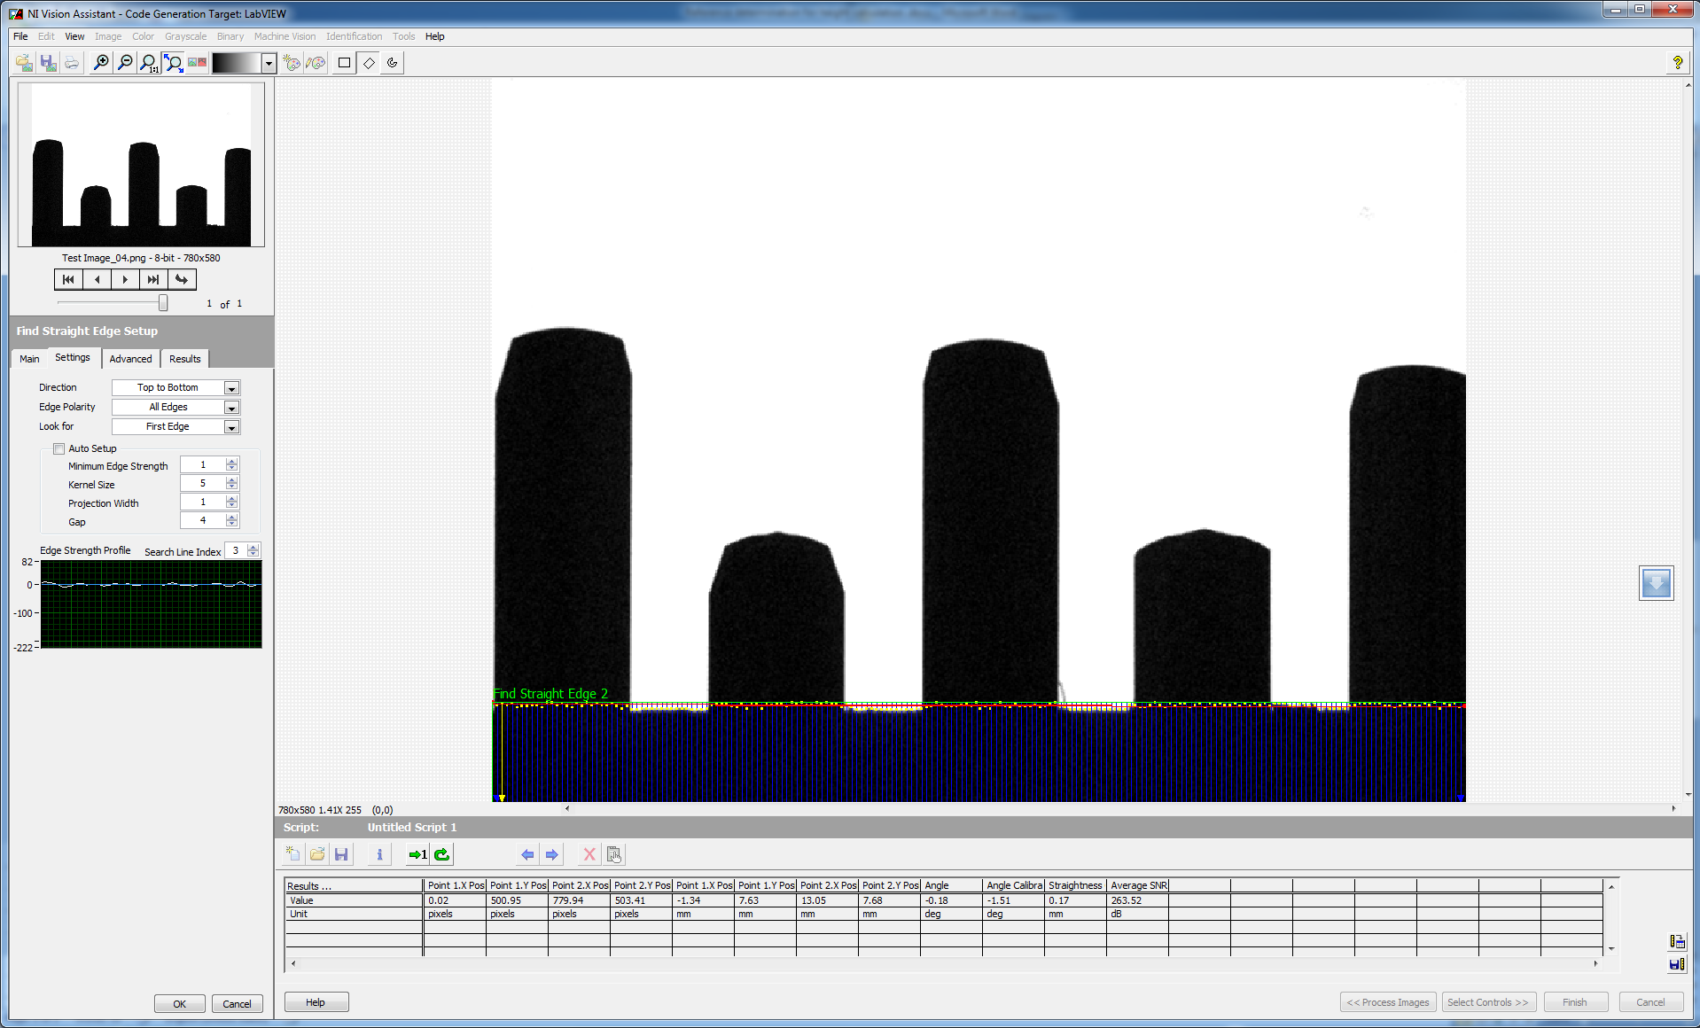

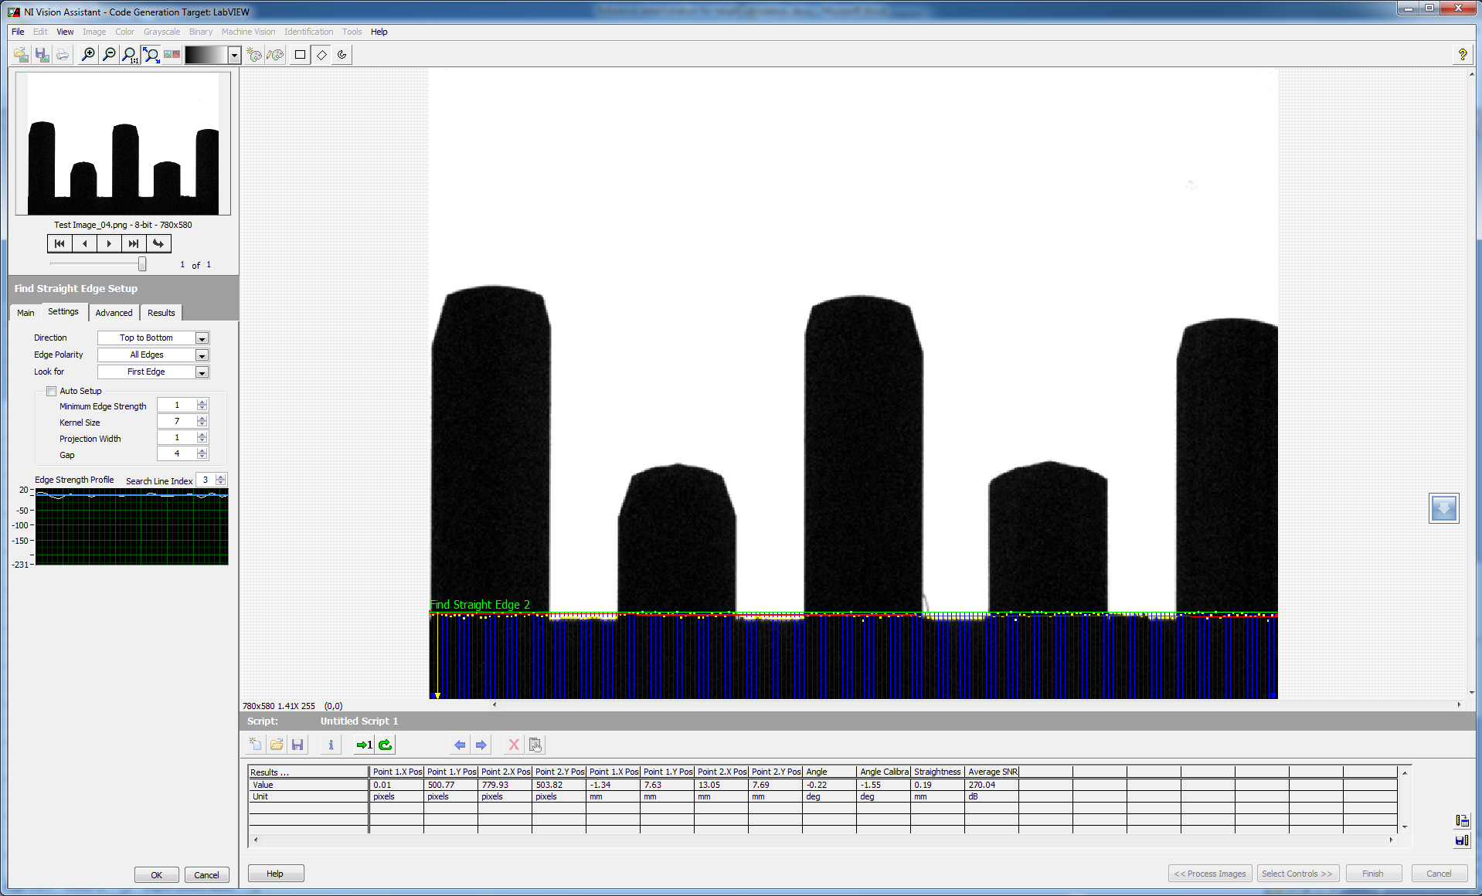

**Approach 2**

Fixing a base Reference (Pin Zero Position) for each pin individually and comparing the height of the pin from this zero position for each pen respectively

Pin 1

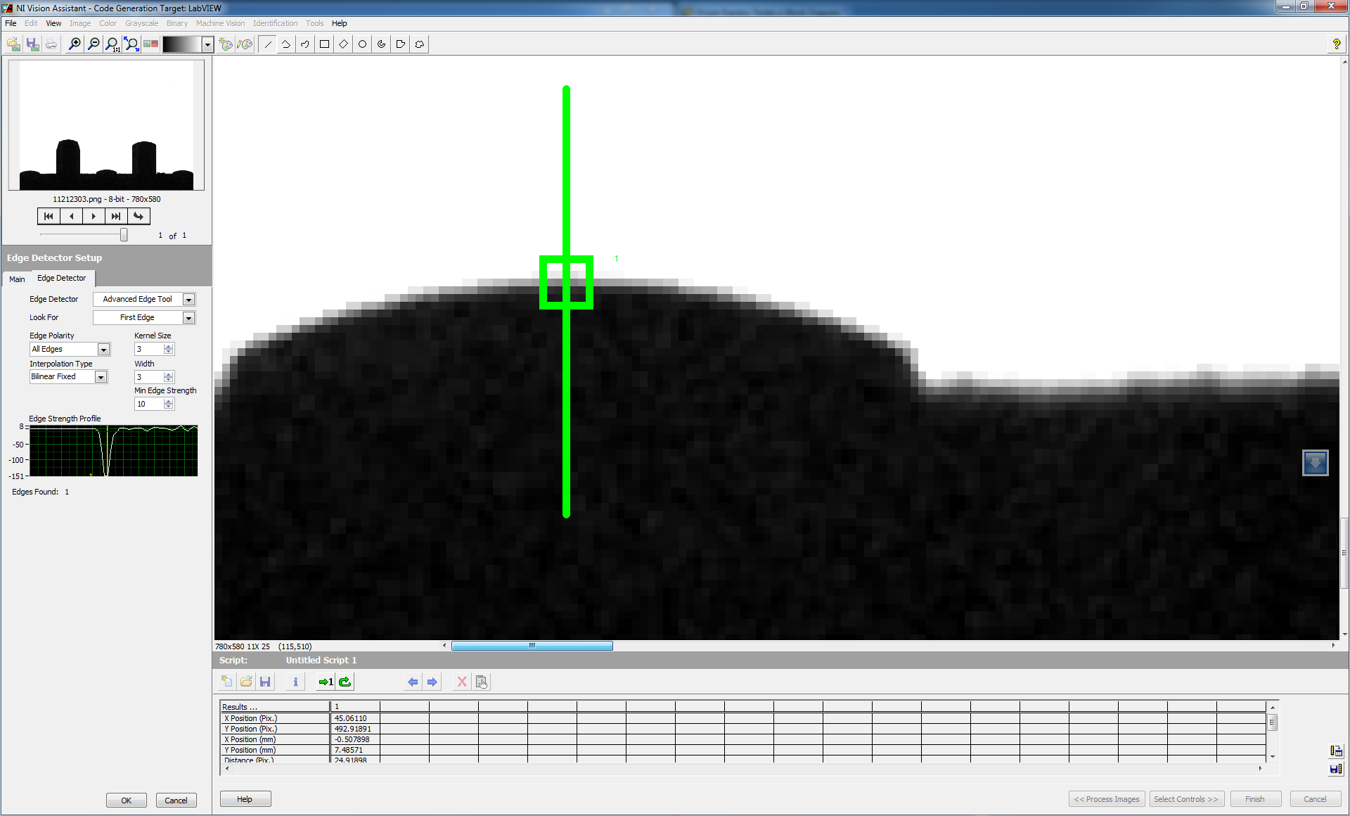

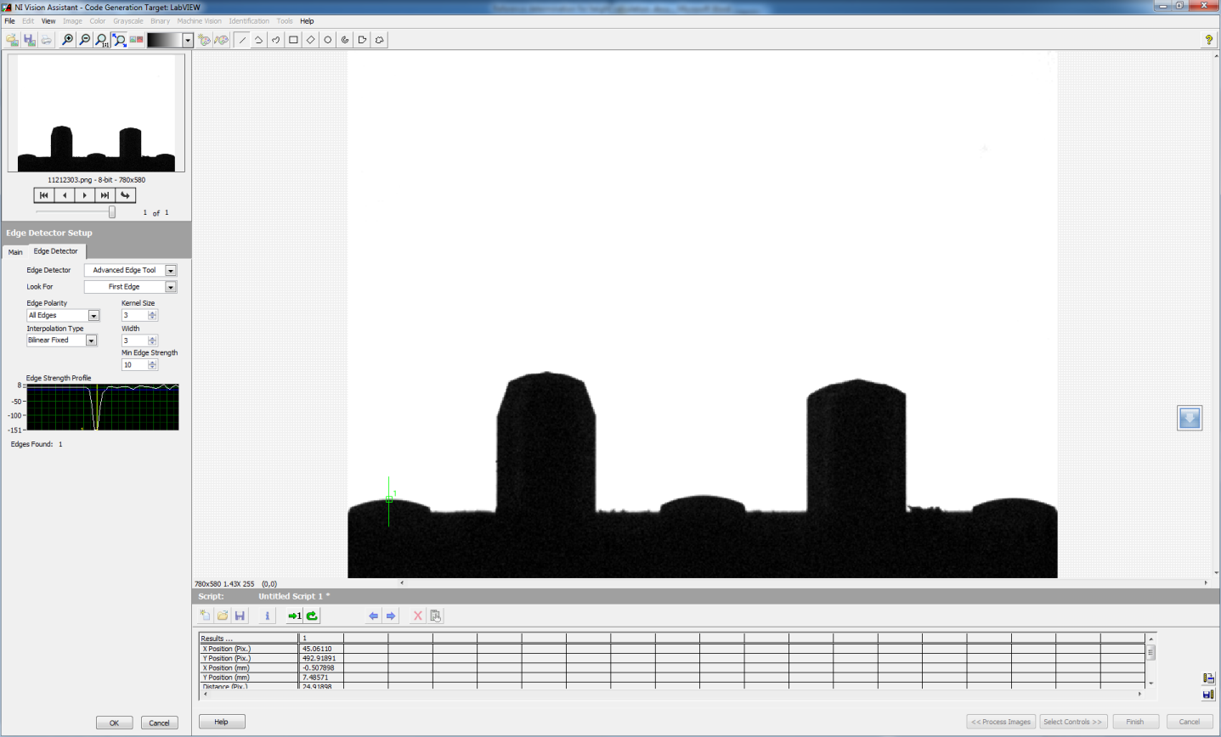

Pixel value - 492

Pin 2

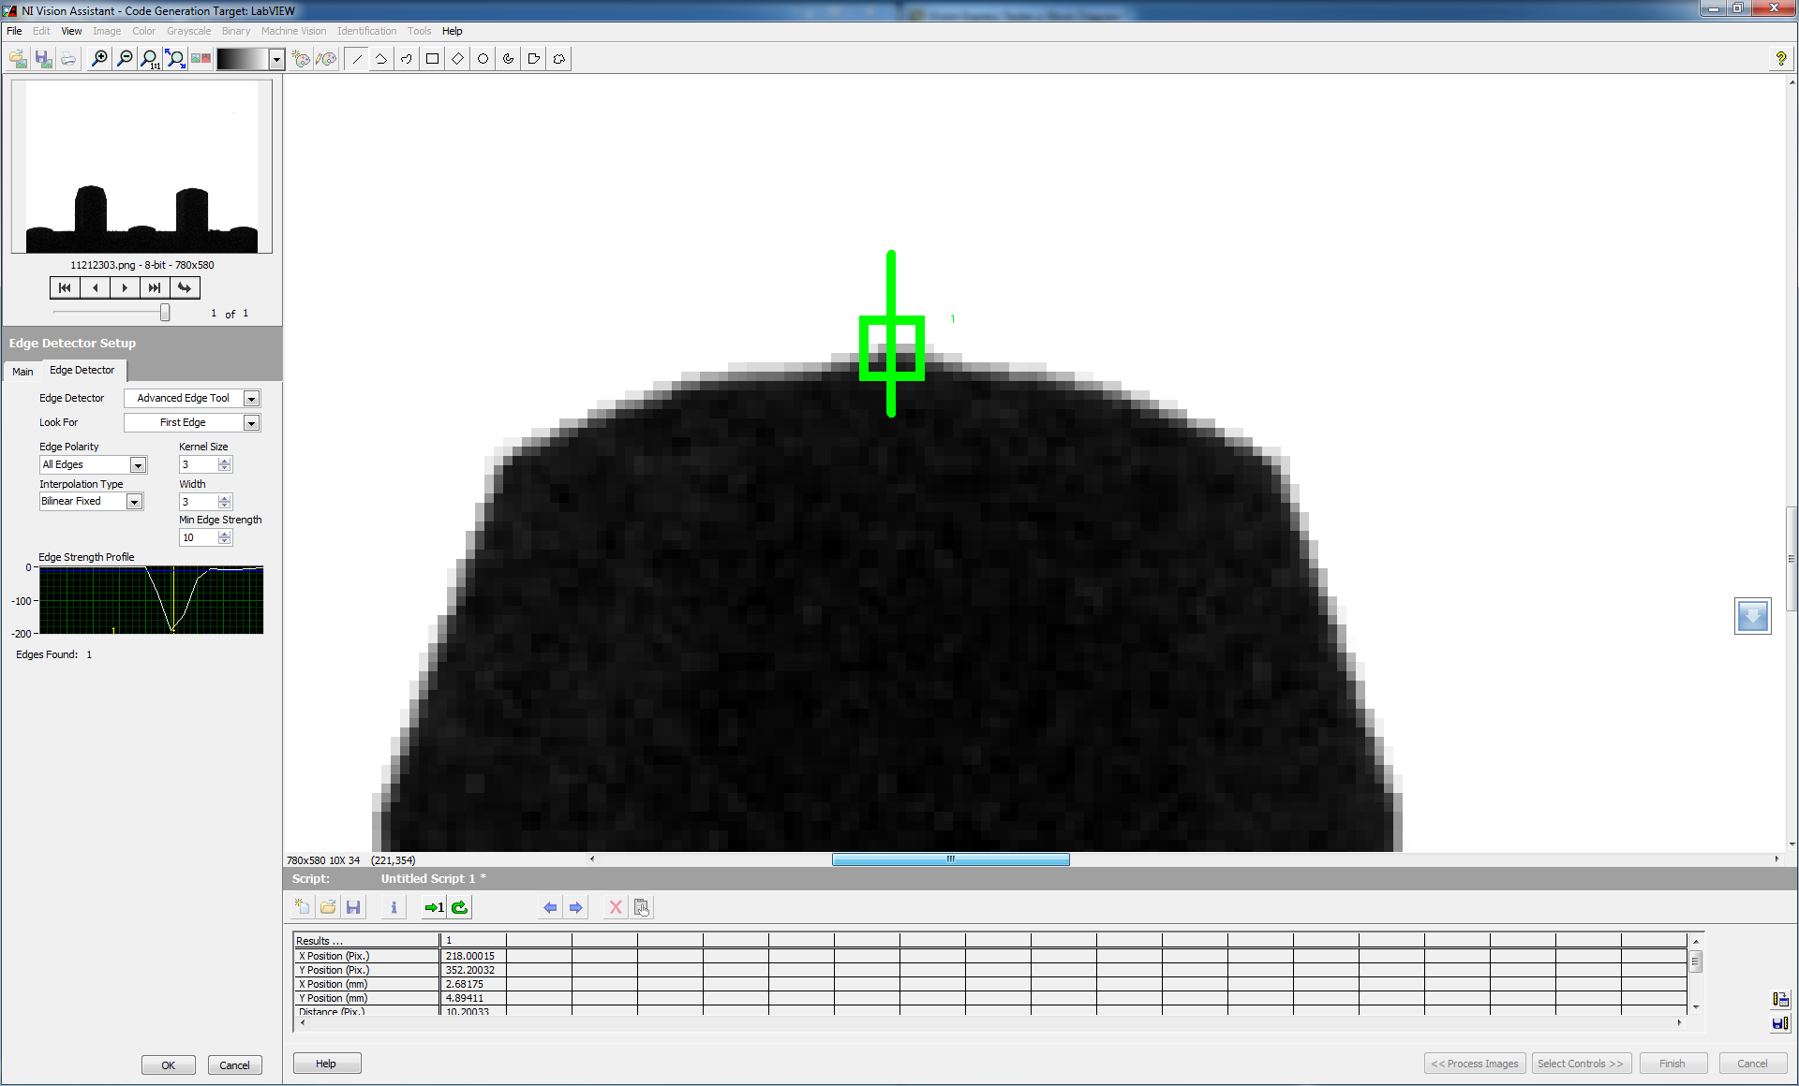

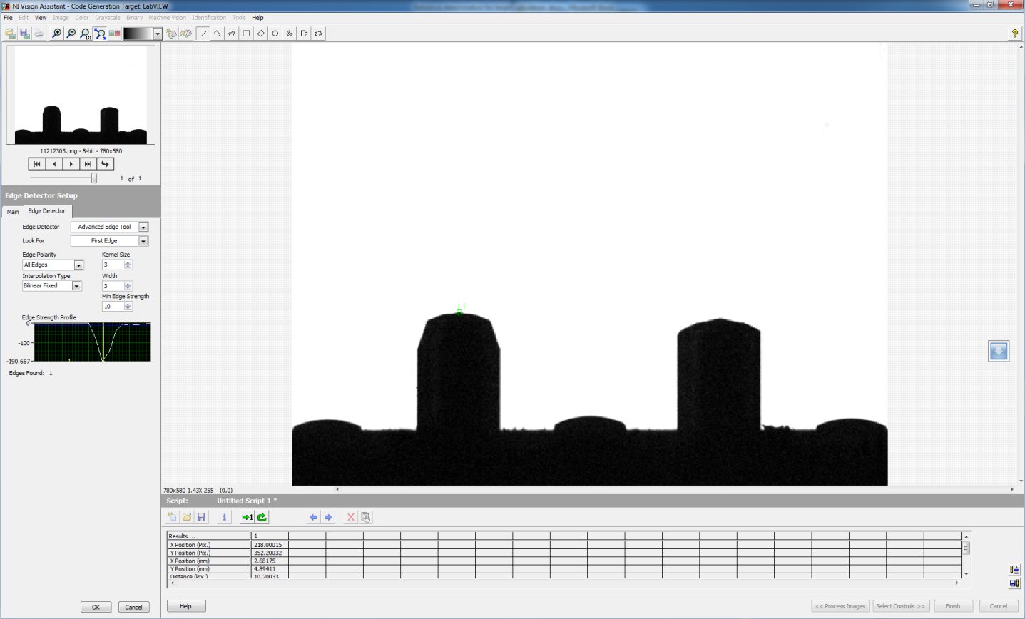

Pixel value - 352

Pin 3

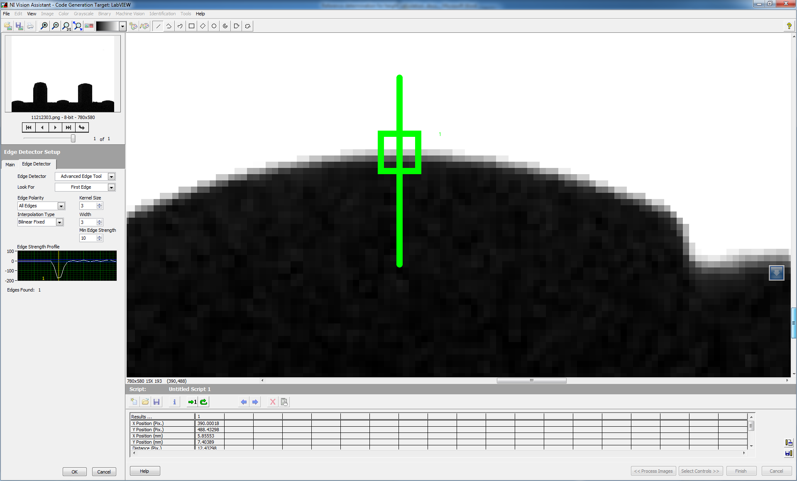

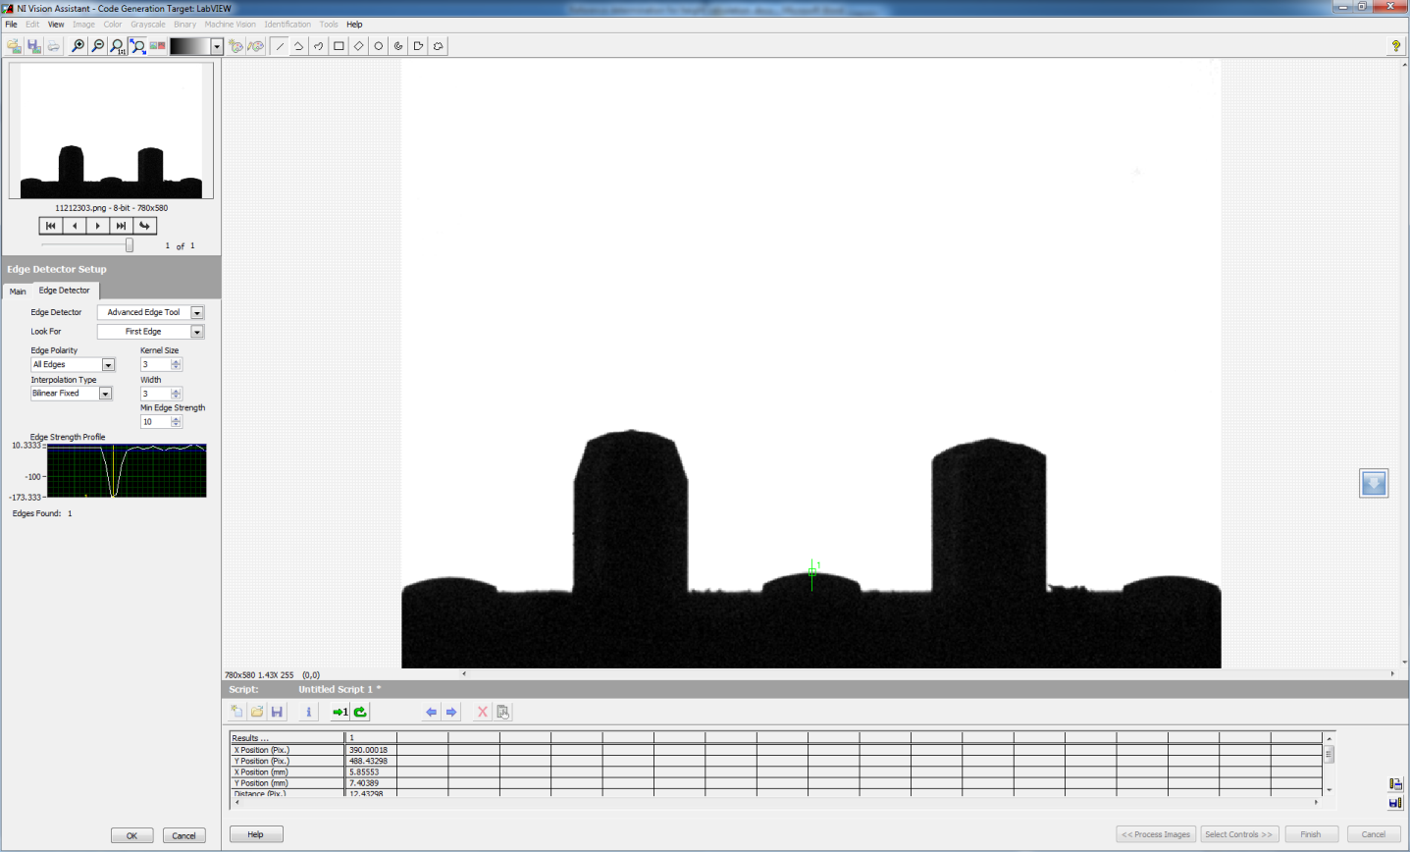

Pixel Value - 488

Pin 4

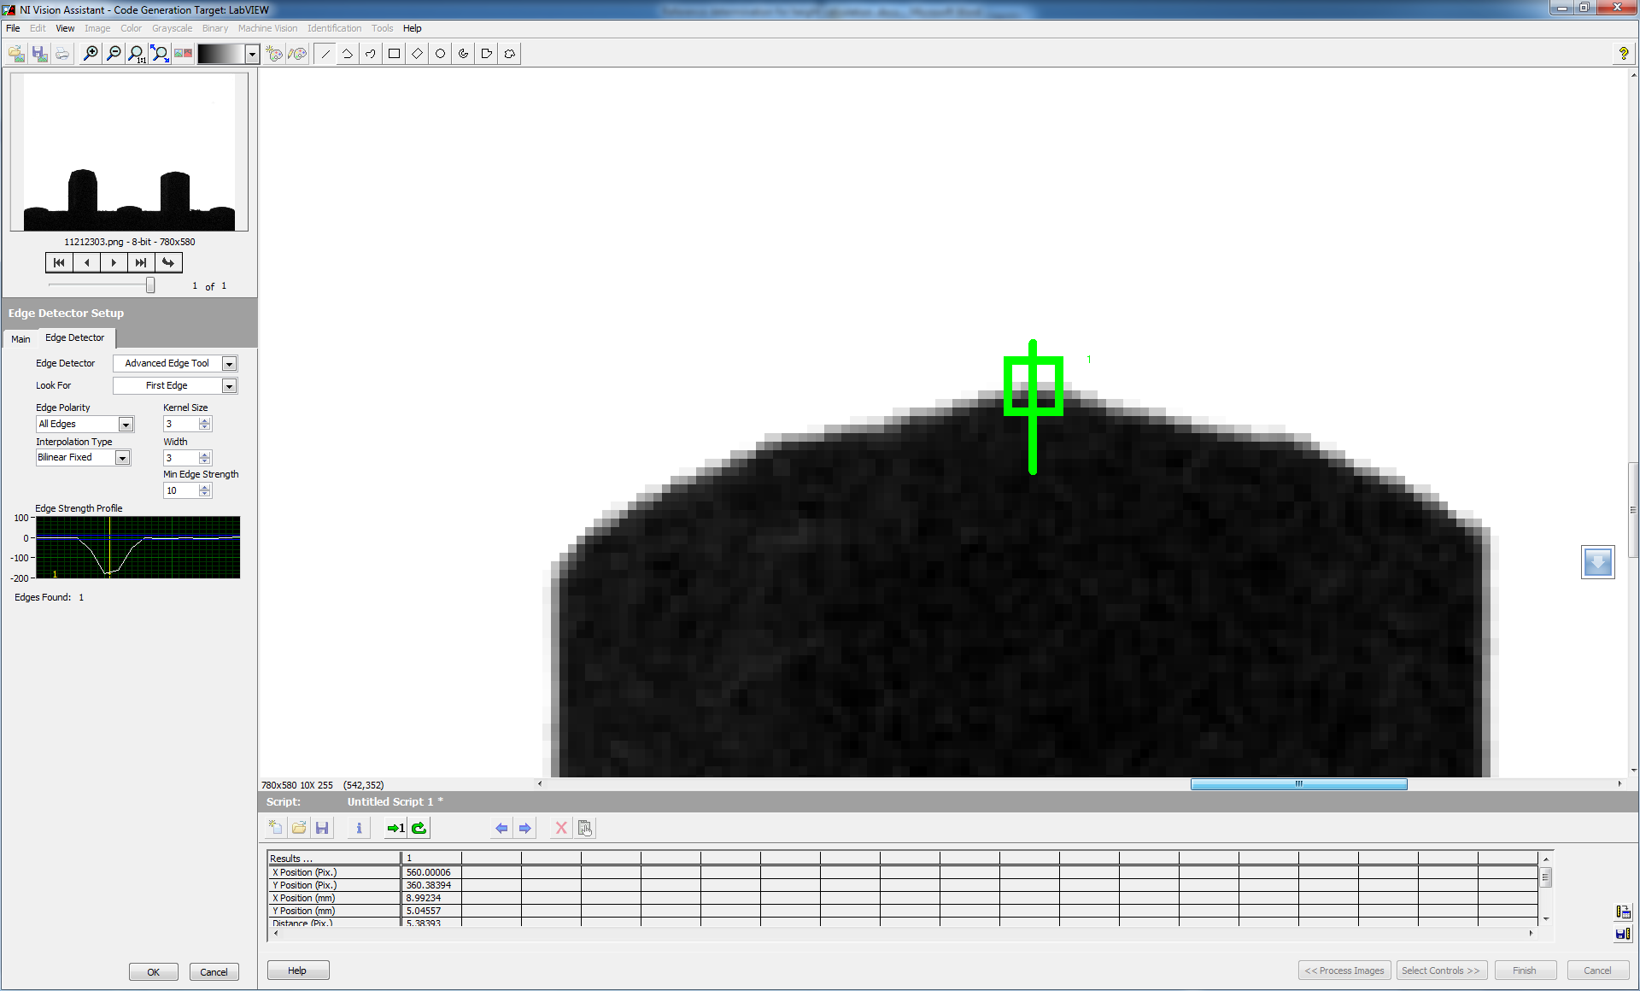

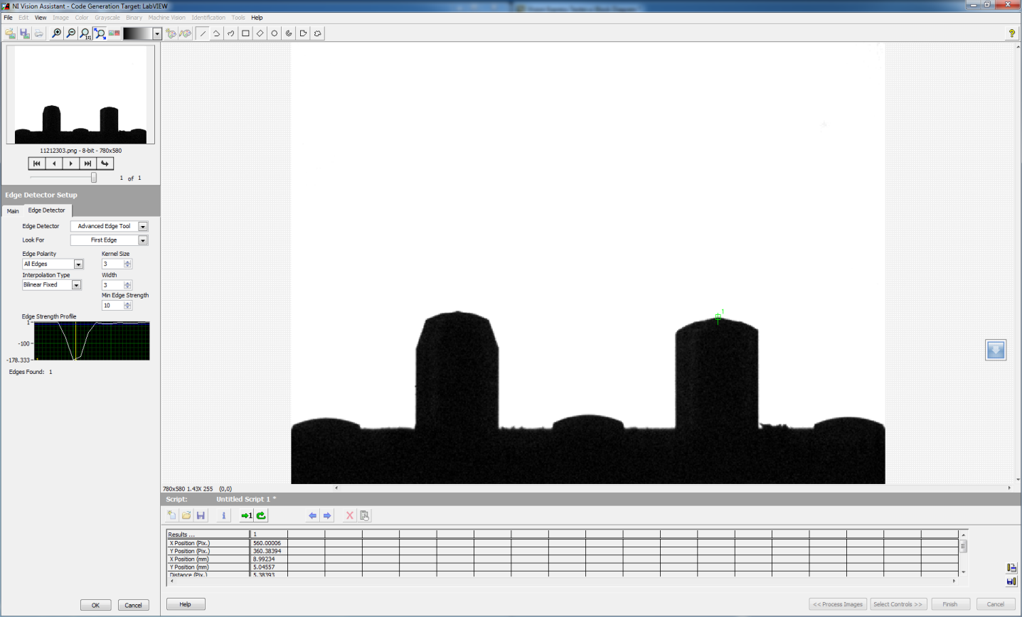

Pixel value - 360

Pin 5

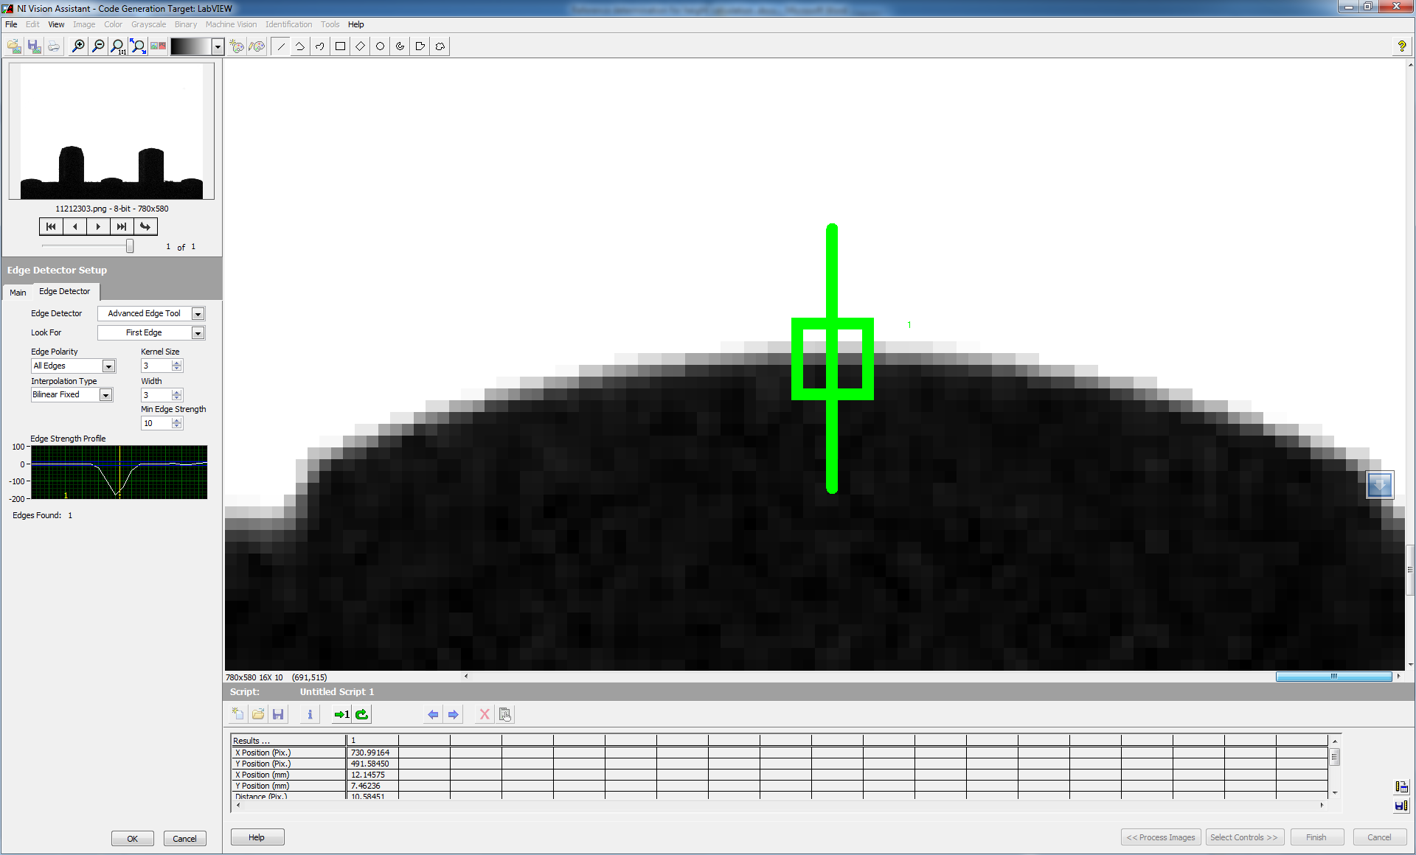

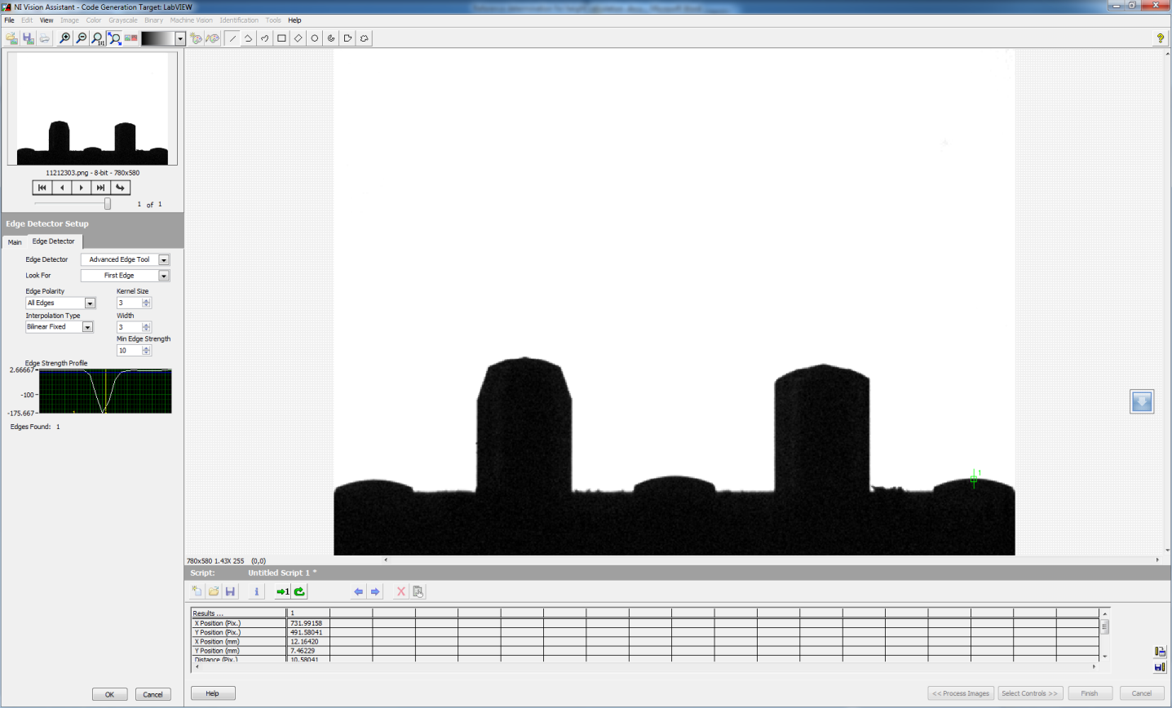

Pixel Value - 491

|  |  |
| --- | --- |
| **Pin Number** | **Pixel Location** |
| 1 | 492 |
| 2 | 352 |
| 3 | 488 |
| 4 | 360 |
| 5 | 491 |